**CREATE NODE-RED SERVICE**

|  |  |
| --- | --- |
| **Date** | **16-11-2022** |
| **Team ID** | **PNT2022TMID19505** |
| **Project Name** | **Project - IOT based safety gadget for child safety monitoring and notification** |
| **Maximum Marks** | **4 Marks** |

**STEPS:**1. First create an IBM cloud account with IBMid and password

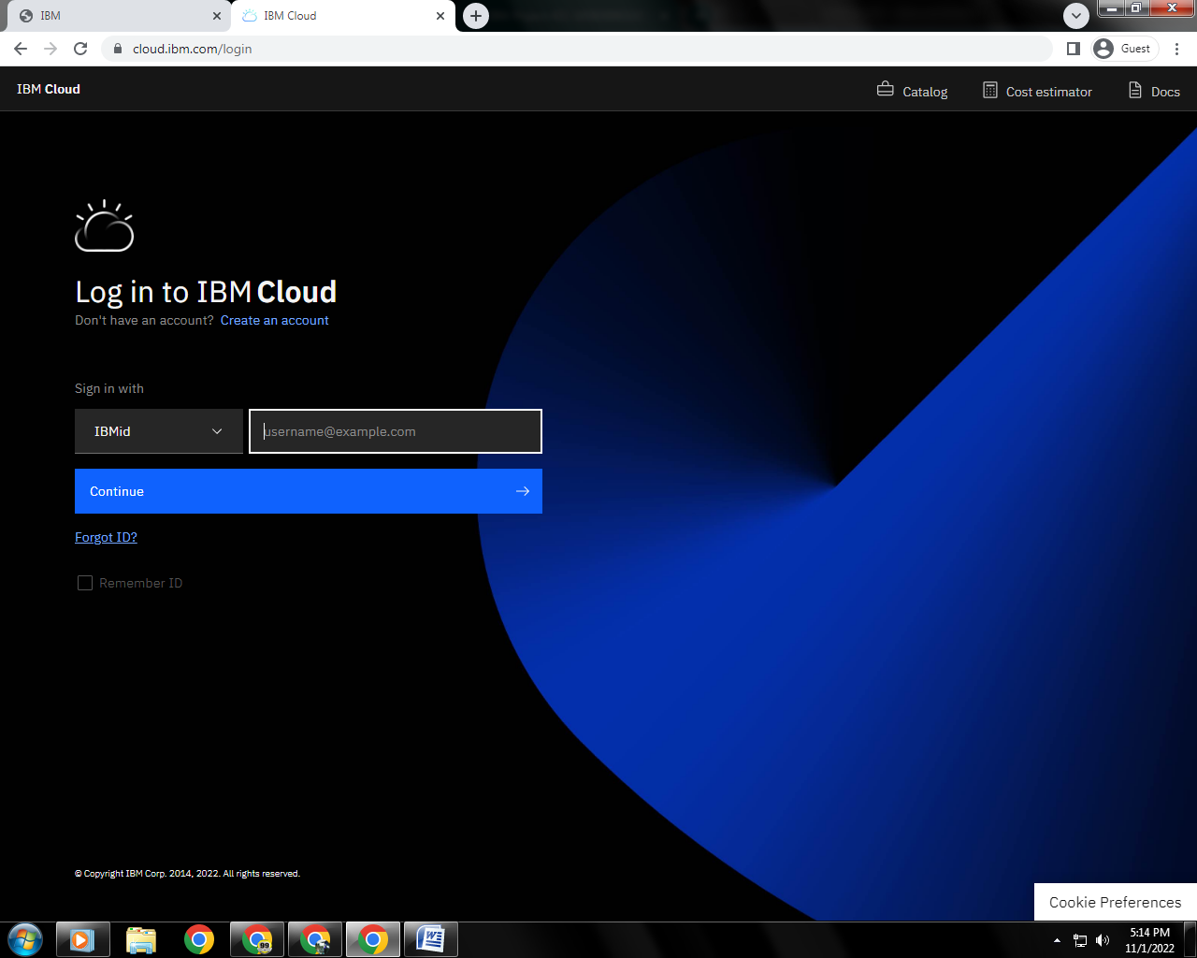

2. Home page of IBM cloud

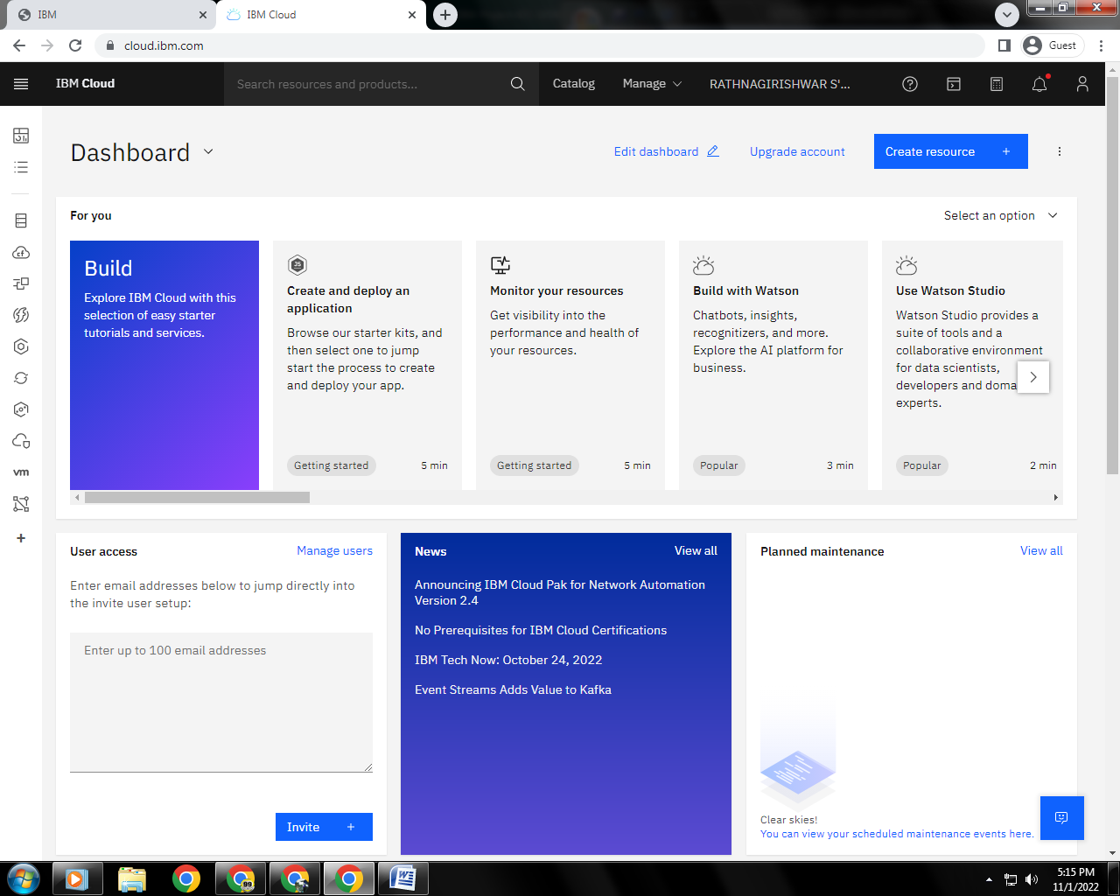

3. Click on the catalog on the top. Search for NODE-RED APP

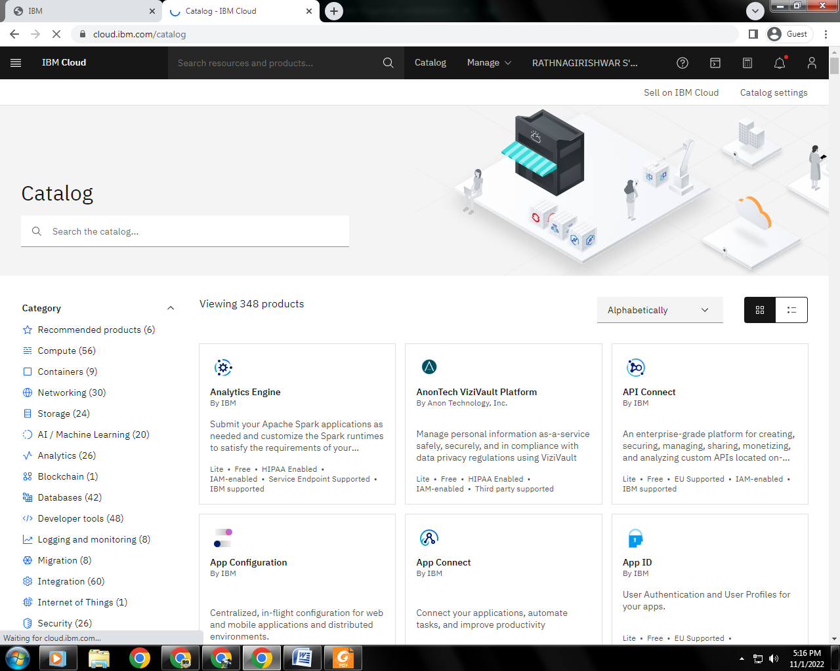

4.Navigated to the App creation page

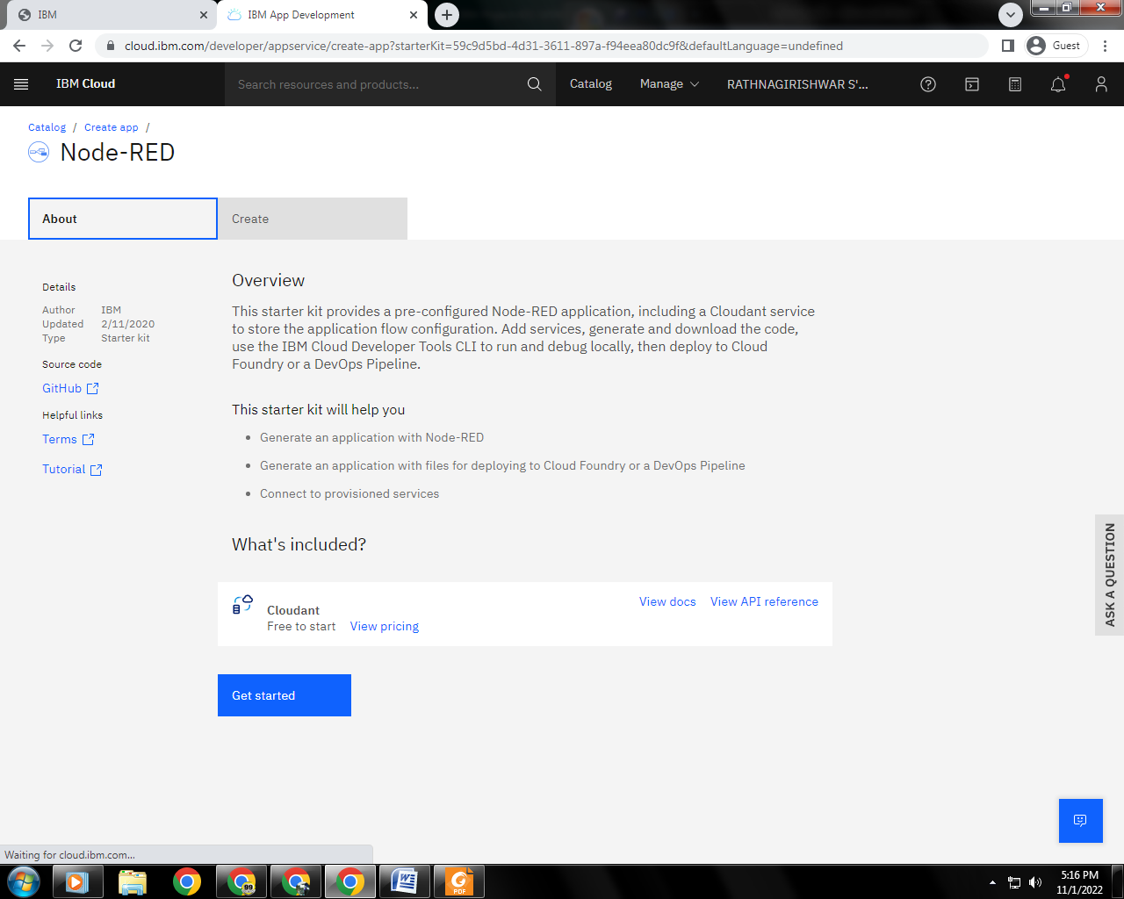

5.Entered project details and clicked on create

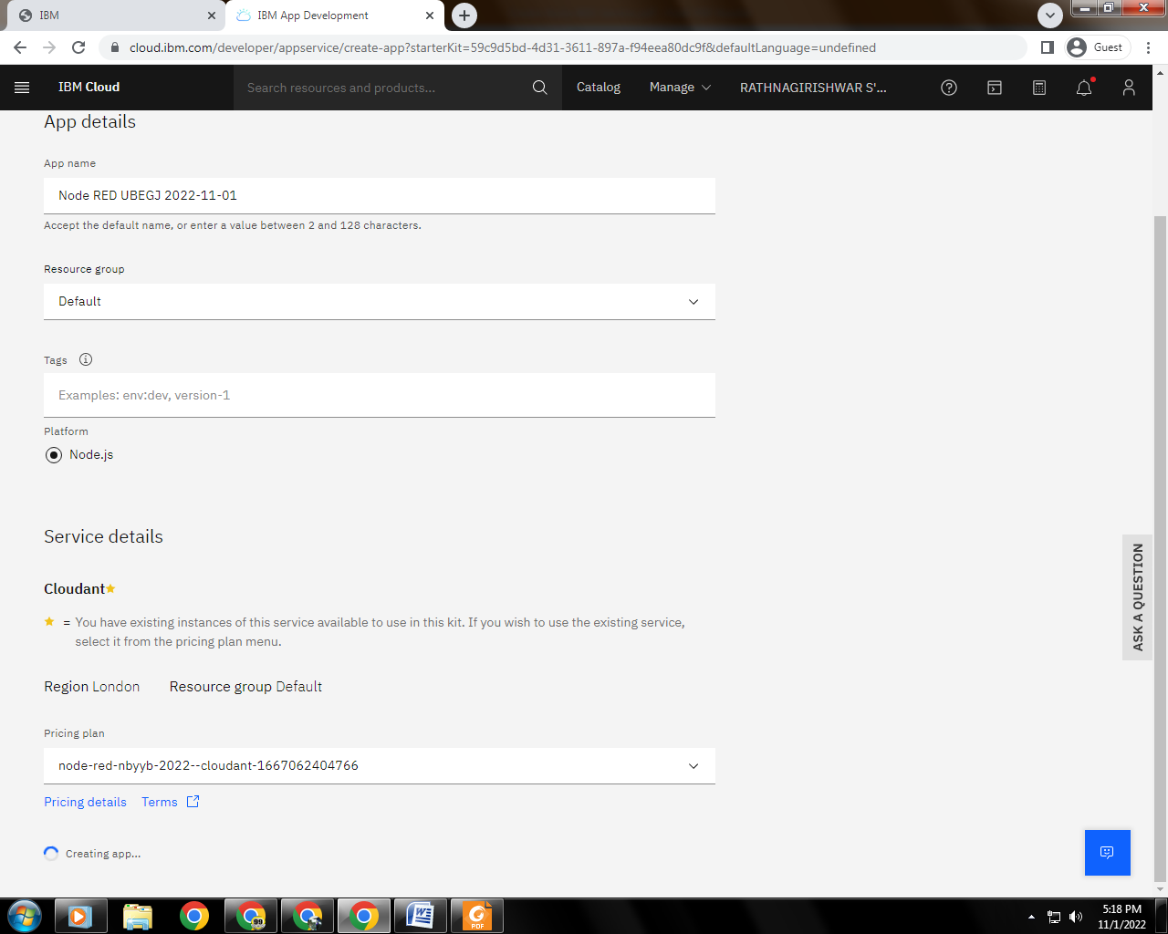

6. Clicking on the “Deploy your App” Button

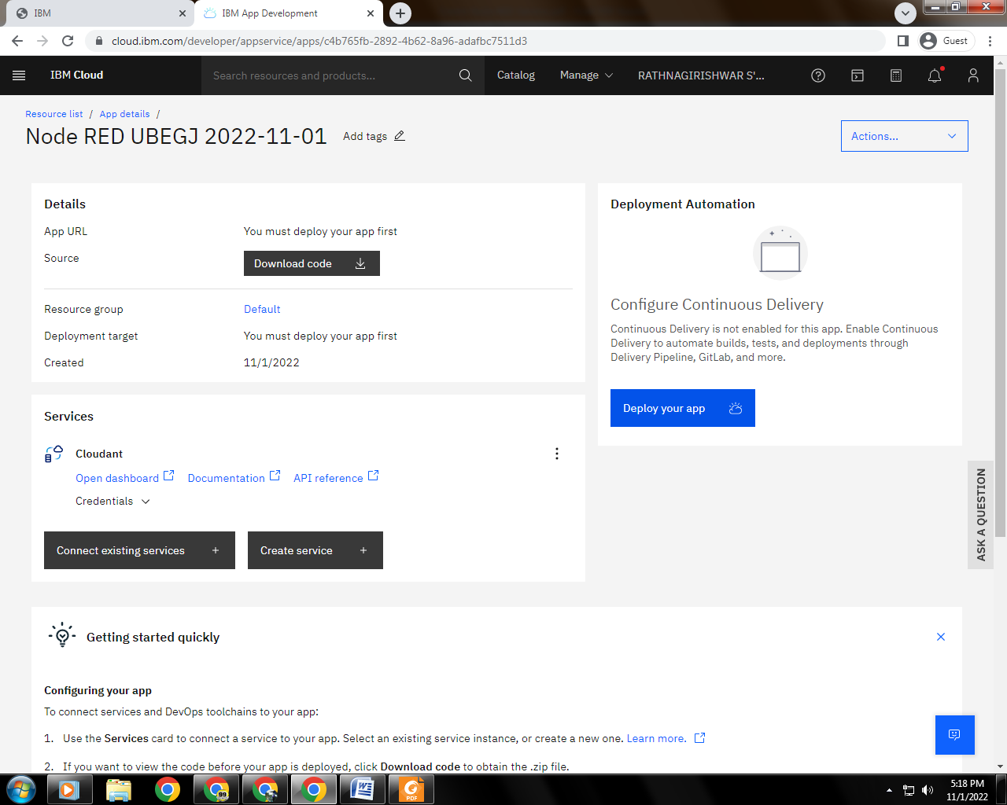

7. Setting up the environment and deploying the app

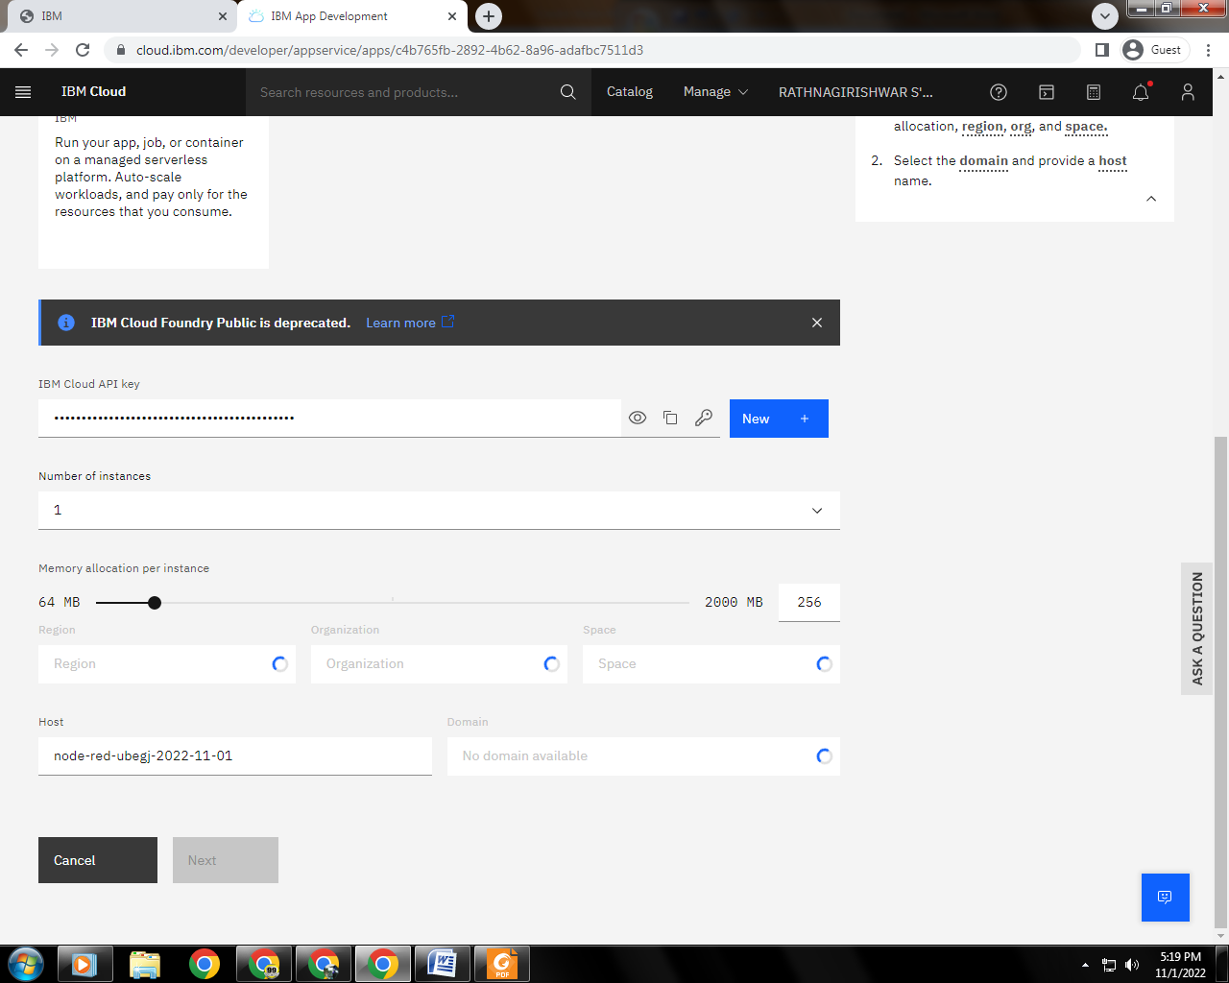

8. Successfully deployed the app

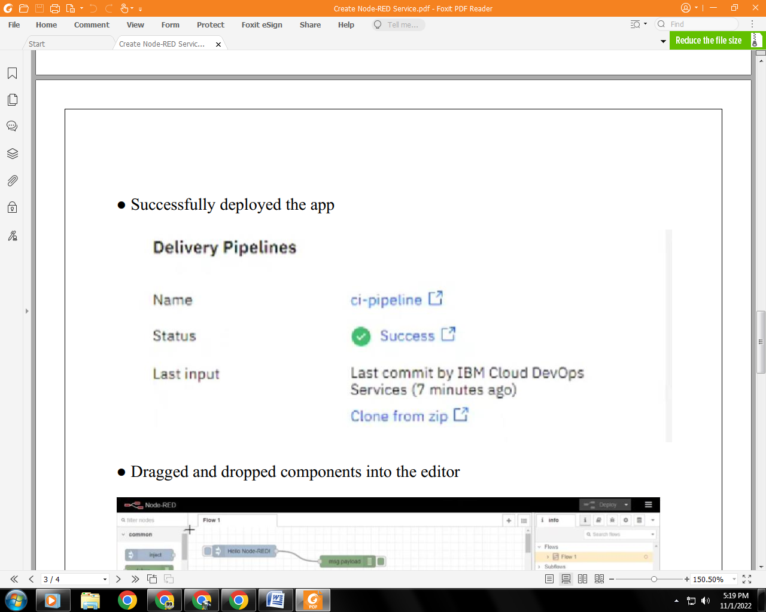

9. Dragged and dropped components into the editor

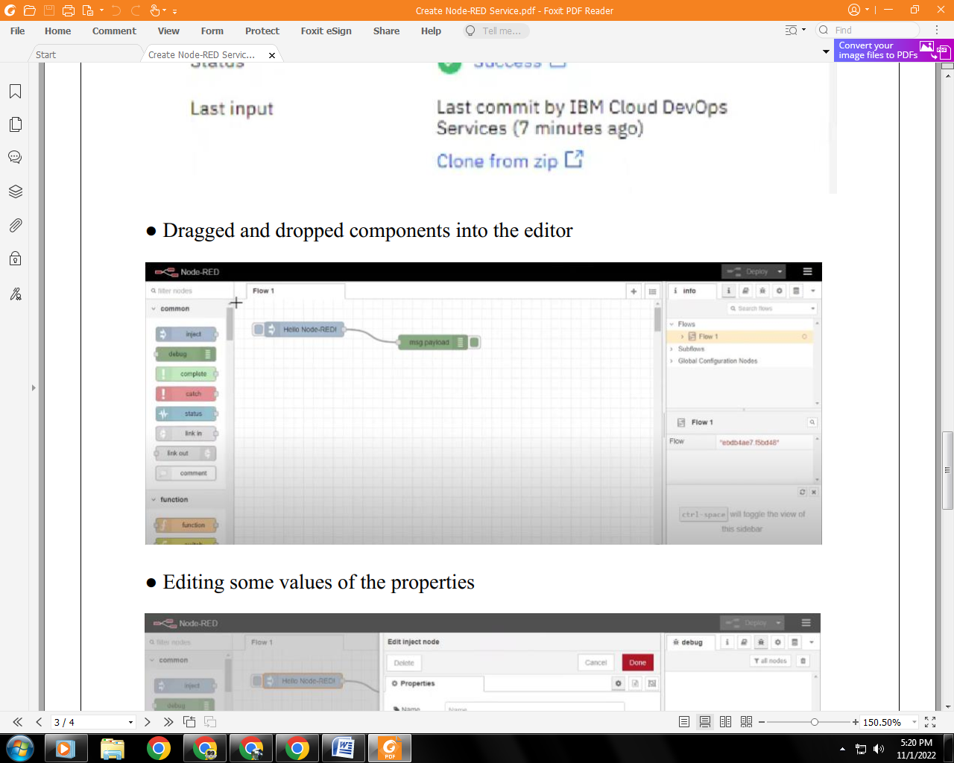

10. Editing some values of the properties

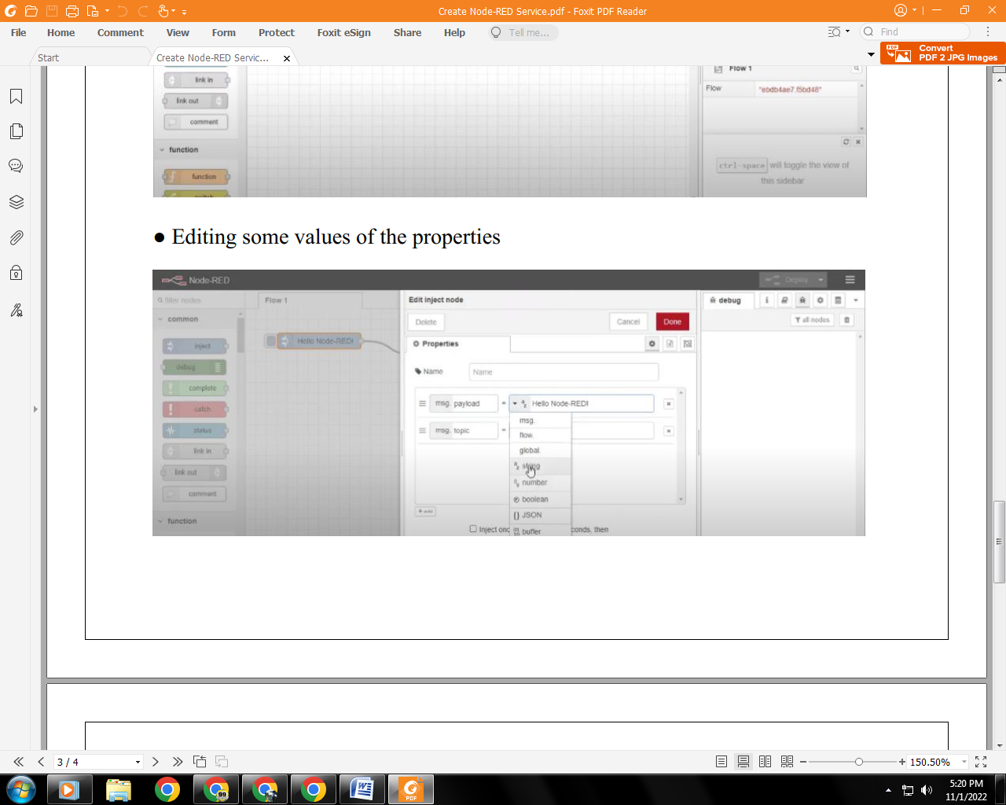

11. Successfully deployed the app

